Make sure that the SDL folders are in the same folder as the project folder (I’m not sure if that is the same for Linux and MacOS or not…)

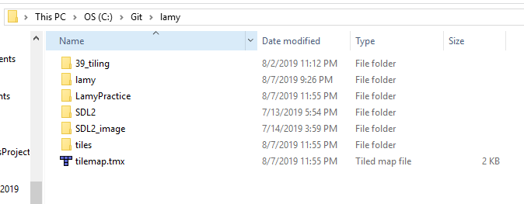

Like this ^^

Again, I am not sure how it is for Linux and MacOS so some of the steps you may already know.

Go into SDL2/lib/x86 and copy the .dll file and paste it inside of the project folder. Then go to SDL2_image/lib/x86 and copy all of the .dll files and paste them inside of the project folder.

Next, in VisualStudio, you open the project:

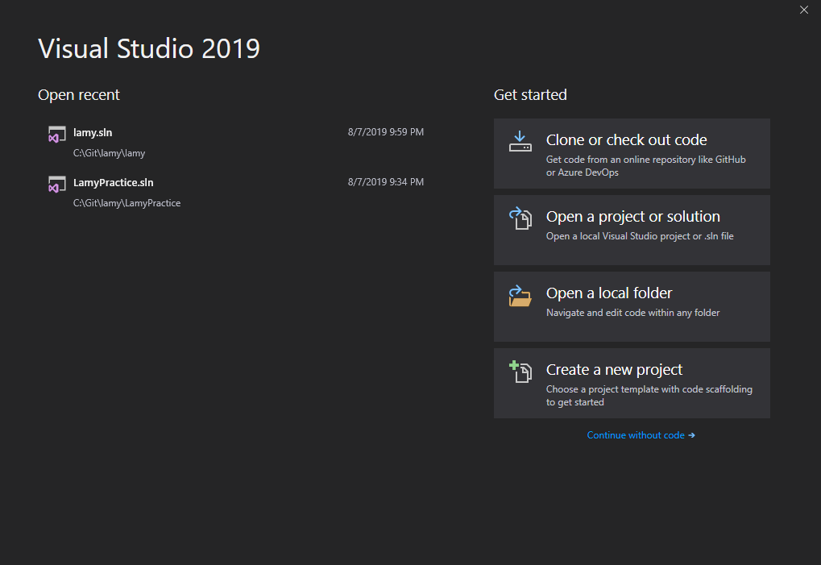

Right click the project

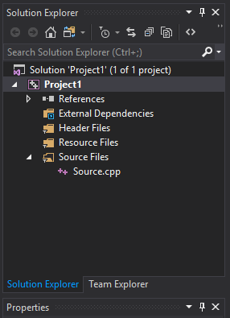

Choose Properties at the bottom of the list

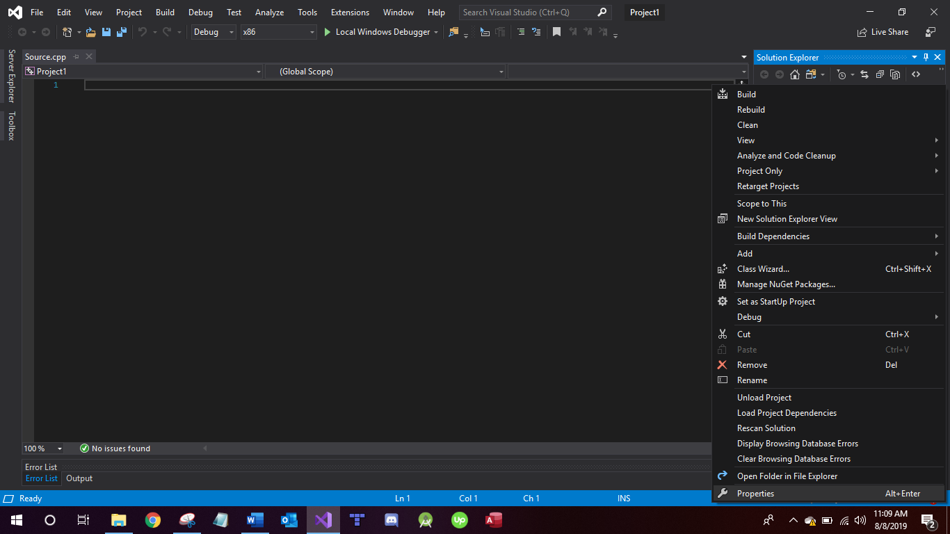

In the properties, expand the C/C++ tab on the left and go to General next to Additional include directories, click in the blank box and click the down arrow and select <Edit…>

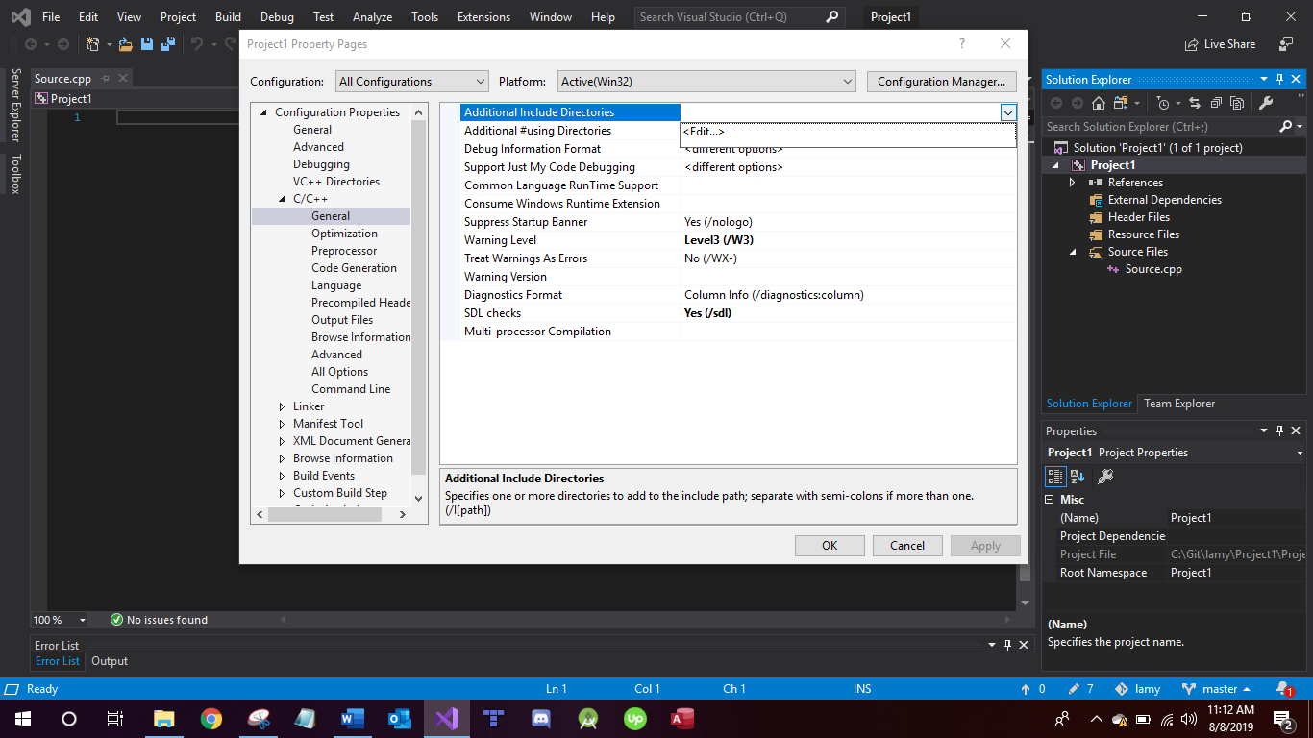

Click the add directory button

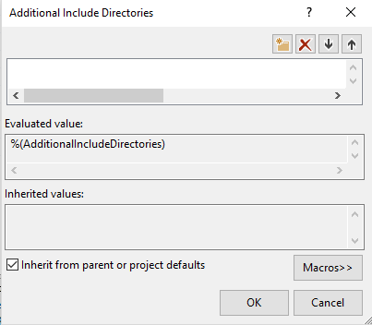

Click the 3 little dots

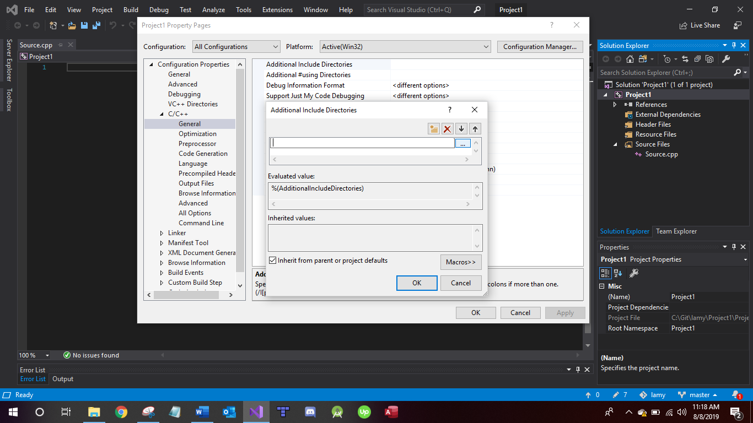

In the file chooser, browse to the SDL2 folder and select the include folder and press Select Folder

Do the same thing for the SDL2_image… include the SDL2_image/include folder once you have included the SDL2/include folder.

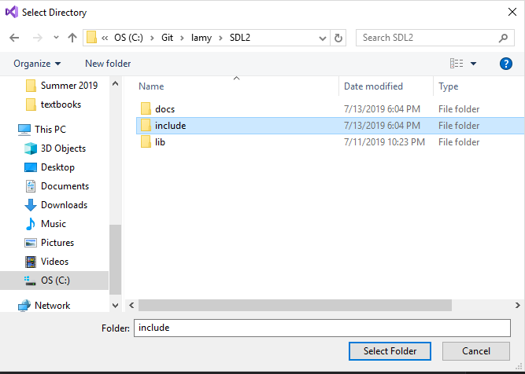

In the Additional Include Directories Dialog box, press OK

Next, expand the Linker tab on the left and go to General

In General, go to Additional Library Dependencies and click <Edit…>

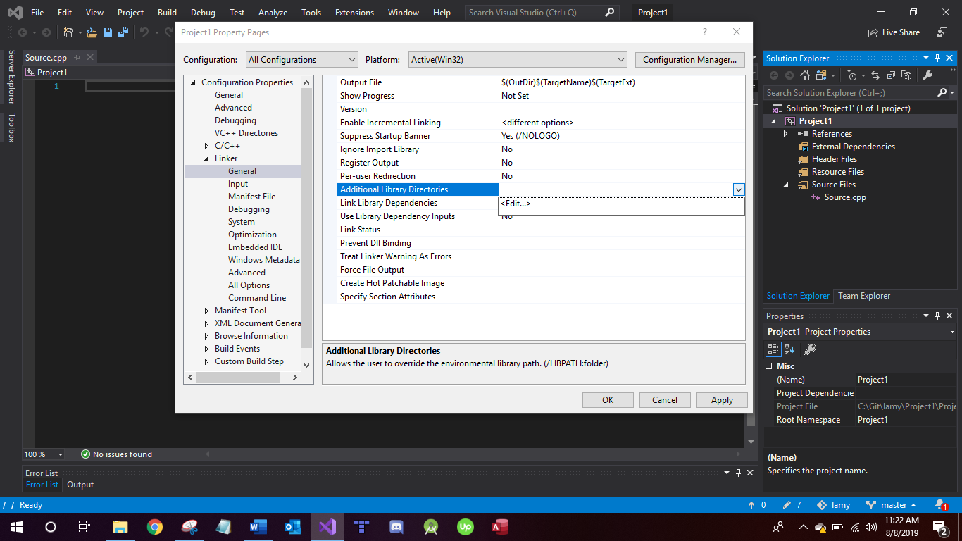

Do the same steps as before to select the SDL2/lib/x86 folder.

Also add another directory and select the SDL2_image/lib/x86 folder.

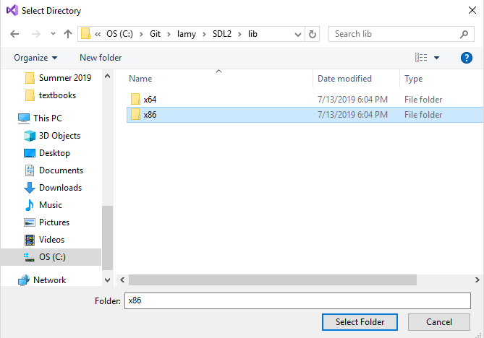

Select the x86 folder.

In the Additional Library Directories dialog box, press OK.

Under the Linker tab on the left, go to Input. In the input tab, you will see Additional Dependencies. You click on that and drop down and click <Edit…> (don’t worry about the files already listed there… I was worried I was messing things up the first time… but it’s really okay.)

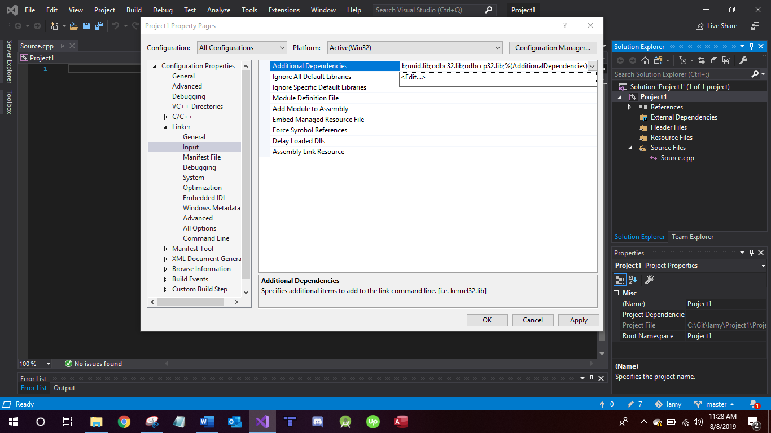

In the dialog box that pops up, there is no add files/folders button. This time, we actually type in some files.

You will type in SDL2.lib and press enter and type in SDL2main.lib and press enter and type in SDL2_image.lib and then press OK

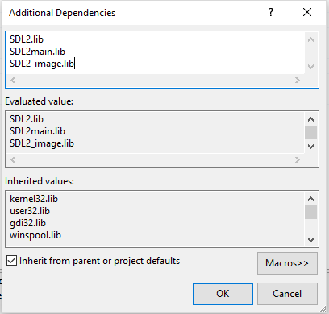

Then under Linker>System make sure the subsystem is set to Console like you see in the picture below

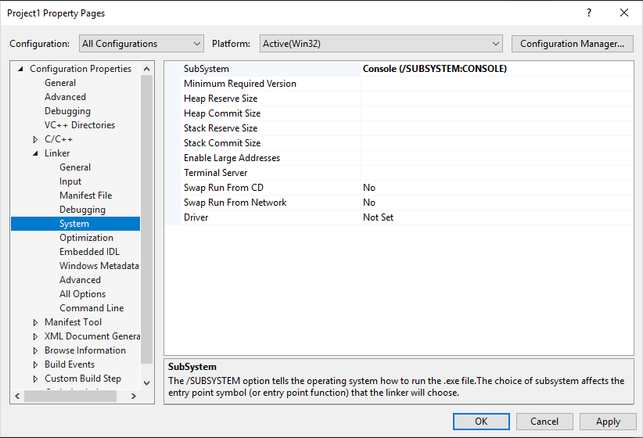

Press Apply and OK.

All Done :D